**Umamah Hussain**

**21L-1858**

**Lab 2:**

**Q.1**

**Books Table:**

create table Books

(

BookID int not null unique,

Title nvarchar(255),

Author nvarchar(255),

PublicationYear int,

ISBN nvarchar(255)

)

Insert into Books([BookID],[Title],[Author],[PublicationYear],[ISBN])

values

(1,'To Kill a Mocking Bird','Harper Lee',1960,'9780061120084'),

(2,'1984','George Orwell',1949,'978045152493'),

(3,'The Great Gatsby','F.Scott Fitzgerald',1925,'9780743273565'),

(4,'Pride and Prejudice','Jane Austen',1813,'9780141439518')

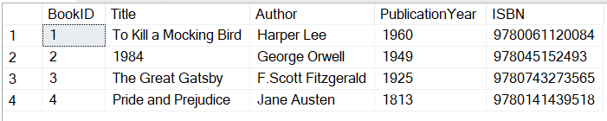

--/Insert a value

Insert into Books([BookID],[Title],[Author],[PublicationYear],[ISBN])

values

(5,'The Catcher in the Rye','J.D Salinger',1951,'9780316769174')

--/Retrieve the details

select* from Books

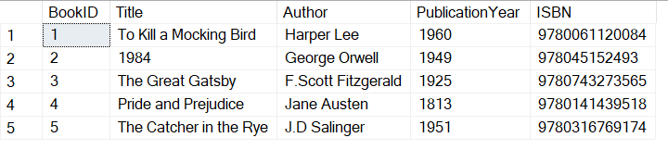

--/update the title

update Books

set Title='Catcher in the Rye 2'

where ISBN='9780316769174'

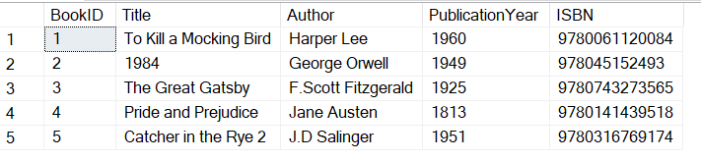

--/delete book with specific ISBN

delete from Books

where ISBN='9780316769174'

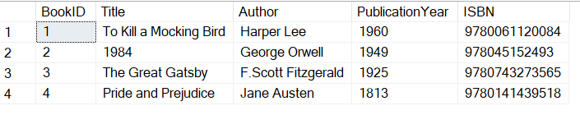

**Q.2**

create table Products

(

ProductID int not null unique,

ProductName nvarchar(255),

Category nvarchar(255),

Price int

)

Insert into Products([ProductID],[ProductName],[Category],[Price])

values

(1,'Laptop','Electronics',800),

(2,'Desk Chair','Furniture',120),

(3,'Smart Phone','Electronics',500),

(4,'Office Desk','Furniture',250),

(5,'Wireless Mouse','Electronics',20),

(6,'Bookshelf','Furniture',150),

(7,'Headphones','Electronics',100) 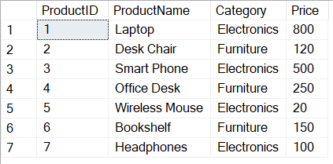

--Retrieve the names of all products that contain the word "Chair" anywhere in their name.

select ProductID,ProductName,Price

from Products

where ProductName like '%Chair%'

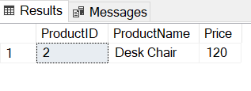

--Retrieve the names and prices of all products in the "Electronics" category.

select* from Products

where Category='Electronics'

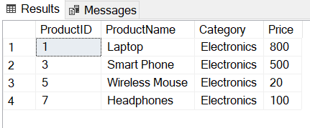

--Retrieve the names and prices of all products with a price less than $200.

select* from Products

where Price<200

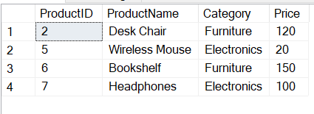

--Retrieve the names and categories of products that contain the word "Desk" anywhere in their name.

select ProductID,ProductName,Price

from Products

where ProductName like '%Desk%'

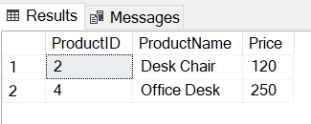

**Q.3**

create table Orders

(

OrderID int not null unique,

CustomerID int,

OrderDate nvarchar(255),

TotalAmount Decimal

)

Insert into Orders([OrderID],[CustomerID],[OrderDate],[TotalAmount])

values

(1,101,'2023-09-01',150.50),

(2,102,'2023-09-02',75.20),

(3,103,'2023-09-03',200.00),

(4,104,'2023-09-04',80.75),

(5,105,'2023-09-05',300.30)

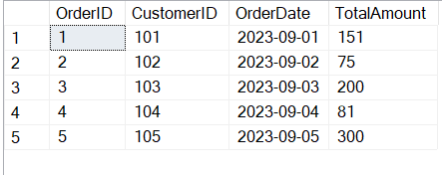

--Calculate the total revenue generated from all orders in the orders table.

select sum(TotalAmount)from Orders

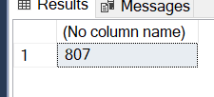

--Find the average order amount in the orders table.

select avg(TotalAmount)from Orders

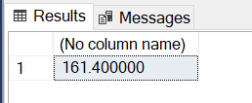

--Update the total_amount column to increase all order amounts by 10%.

select OrderID,CustomerID,OrderDate,TotalAmount, 1.1*TotalAmount as UpdatedAmount

from Orders

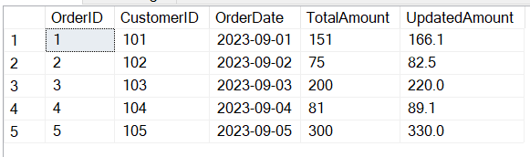

--Select orders where the total amount is greater than $500.

select* from Orders

where TotalAmount>500

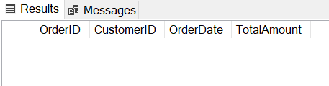

--Calculate the sum of total amounts for orders placed in 2023

select sum(TotalAmount)from Orders

where OrderDate like '2023%'

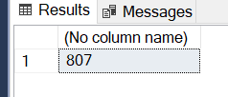

**Q.4**

create table employees

(

EmployeeID int not null unique,

FirstName nvarchar(255),

LastName nvarchar(255),

DepID int

)

Insert into employees([EmployeeID],[FirstName],[LastName],[DepID])

values

(1,'John','Smith',101),

(2,'Sarah','Johanson',102),

(3,'Michael','Williams',103),

(4,'Emily','Davis',104),

(5,'David','Lee',105),

(7,'Anna','Woo',null)

create table departments

(

DepID int not null unique,

DepName nvarchar(255)

)

insert into departments([DepID],[DepName])

values

(101,'Sales'),

(102,'Marketing'),

(103,'Finance'),

(104,'Human Resources'),

(105,'Research and Development')

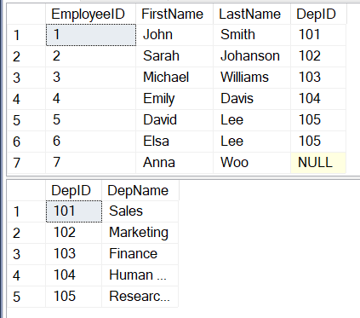

--Perform a union operation between the employees and departments tables to get a combined list of employees and department names.

select E.EmployeeID,E.FirstName,E.LastName,D.DepID,D.DepName

from employees E, departments D

where D.DepID=E.DepID

select E.EmployeeID,E.FirstName,E.LastName,D.DepID,D.DepName

from employees E

join departments D on D.DepID=E.DepID

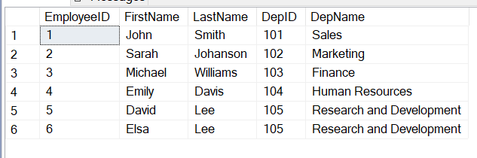

--Find the employees who are not assigned to any department using the set difference operation.

select A.EmployeeID,A.FirstName,A.LastName,A.DepID

from employees A

where A.DepID is null

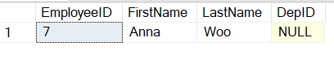

--Determine the common department(s) between two sets of employees using the intersection operation.

select distinct A.EmployeeID,A.FirstName,A.LastName,A.DepID

from employees A, employees B

where A.DepID=B.DepID and A.EmployeeID<>B.EmployeeID

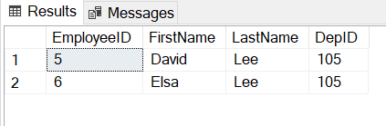

--Determine the common department(s) between two sets of employees using the intersection operation.

select distinct A.EmployeeID,A.FirstName,A.LastName,A.DepID

from employees A, employees B

where A.DepID=B.DepID and A.EmployeeID<>B.EmployeeID

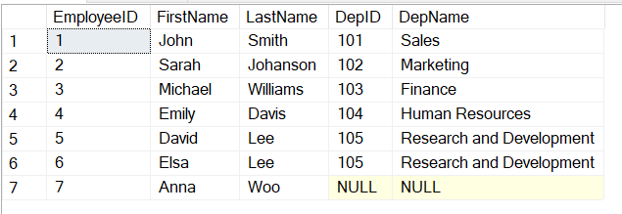

--Find the departments that have no employees assigned to them.

select * from departments D

join employees E on E.DepID=D.DepID and D.DepID is null

